Prepositions of Relation

🔹 What Are Prepositions of Relation?
# Source: AI Source: Provided by: [Data Path: Persons Table -> ID Column: 1, Name_En Column: Motasem Essam] -> From: [Chatgpt (GPT-4-turbo)] on [7/28/2025]
Prepositions of relation show the connection or relationship between two elements — such as people, objects, ideas, or actions.
They describe how things are related in terms of association, ownership, reference, or involvement.

✅ Common Prepositions of Relation
# Source: AI Source: Provided by: [Data Path: Persons Table -> ID Column: 1, Name_En Column: Motasem Essam] -> From: [Chatgpt (GPT-4-turbo)] on [7/28/2025]
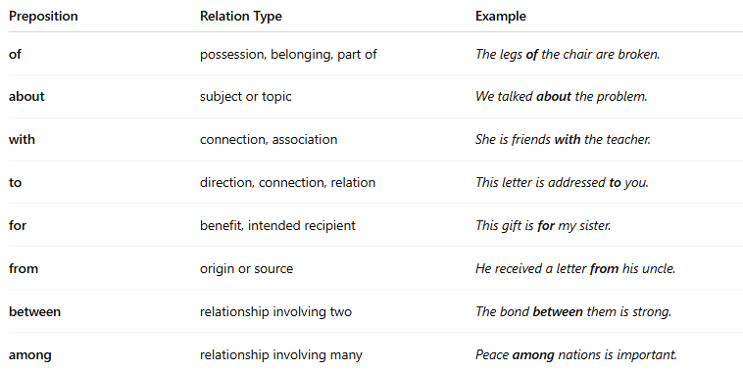
Preposition | Relation Type | Example
of | possession, belonging, part of | The legs of the chair are broken.
about | subject or topic | We talked about the problem.
with | connection, association | She is friends with the teacher.
to | direction, connection, relation | This letter is addressed to you.
for | benefit, intended recipient | This gift is for my sister.
from | origin or source | He received a letter from his uncle.
between | relationship involving two | The bond between them is strong.
among | relationship involving many | Peace among nations is important.

📚 Example Sentences
# Source: AI Source: Provided by: [Data Path: Persons Table -> ID Column: 1, Name_En Column: Motasem Essam] -> From: [Chatgpt (GPT-4-turbo)] on [7/28/2025]
- The color of the sky is blue.
- I care about your happiness.
- She works with children.
- This idea is similar to mine.
- He came from Italy.
- They discussed peace among neighbors.

